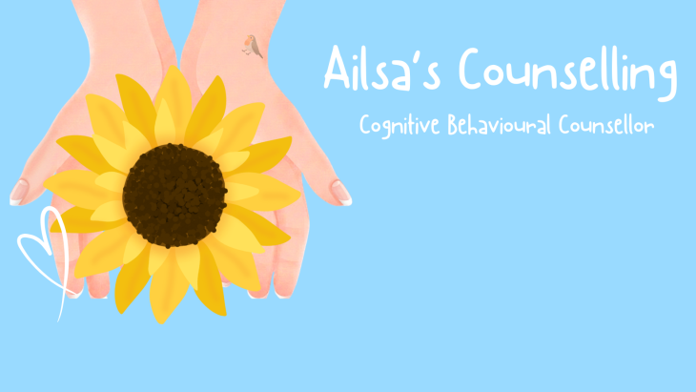 GDPR INFORMATION

The General Data Protection Regulation (GDPR) came into force on 25 May 2018. This regulation was introduced to strengthen data protection for individuals like you.
WHAT DO I DO WITH YOUR INFO?
I keep the info that I collect electronically and on paper, together this is called your Case Record. People who are involved in helping you may see what has been collected; this means we can all make the right decisions about what is best for you.
Computer records are always password protected using 2 step Authentication which adds a second layer of security to your Case File. Paper records are always stored in lockable cabinets in a safe location.
WHO DO I SHARE IT WITH?
The info that I hold will not be shared with anyone other than the people who need to know it so that they can help you properly.
In some cases it may be shared with your parent/guardian/social worker – to update them with how I am helping you.
I will always ask permission though before sharing any information. If you are 13 or over, I will ask your permission, if you are under 13, I will ask your parent, guardian or carer.
Confidentiality means that anything you tell me is private, however, if you tell me something that makes me worried about your safety, or the safety of someone you know, I might have to share this with other people, this is part of my duty of care to keep you safe. This could include planned harm to others, Terrorism Offences, if a person you know is at risk from harm/abuse or if someone is considering suicide or seriously hurting themselves.
WHAT INFO DO I COLLECT AND WHY?
Initially I will start by asking your correct name and address, your date of birth and who we can contact if we need to. I will also make sure you know why you have been referred. Also if you have any allergies I need to be aware of. I will also record details of sessions we have had , details of support and activities we have done so that I can look back to make sure I am helping you in the best way possible.

