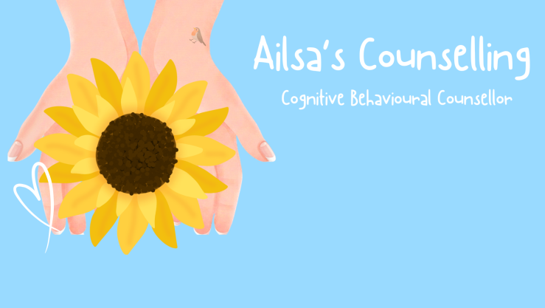 CANCELLATION POLICY

- PURPOSE OF THIS POLICY
Ailsa’s Counselling dedicate a consistent recurring time slot for your child. Consistency is vital to your child’s progress, that hour belongs strictly to them. I cannot easily fill last-minute gaps on our waiting list – To maintain a fair and sustainable practice, I ask that you adhere to the following guidelines please.

- NOTICE REQUIRED FOR CANCELLATION
Standard notice, I require 24 hours notice to cancel or reschedule a session.
Email ailsacounsellor@icloud.com or alternatively ring or text Ailsa’s Counselling on 07443 538057.

- FEE STRUCTURE
Late cancelation with less than 24 hours notice will incur a fee of £50 (Full session fee).
No show/no notice - £50 (Full session fee).
Payment due upon booking session (payment confirms booking).

- WHAT QUALIFIES AS AN EMERGENCY?
Fees will be waived for medical emergencies or extreme weather conditions.
Standard fees apply for non-emergencies.

- EXCESSIVE CANCELLATIONS
Consistency is prerequisite for successful Child Therapy, missing more than 3 sessions in a row will trigger a review of your Child’s slot, which may result in discharge from the service.

Thankyou for your understanding.

